Windows 2000-XP
V.N.C.
Virtual Network Computing

Michel Cabaré
Septembre 2004 Ver: 1.0

Institut National Polytechnique de Grenoble

DÉPARTEMENT FORMATION CONTINUE

table des matiÈres

What V.N.C. IS 3
Virtual Network Computing 3
Free Download 3
Installing VNC 4
Using VNC 6
Virtual Network Computing 6
Advanced features 8
register parameters for VNC server 8
Using a Web connection instead of VNC viewer 9
Changing default port of VNC server 10
VNC – FireWALL - SSH 11
register parameters for VNC server 11

What V.N.C. IS

Virtual Network Computing
VNC (Virtual Network Computing) software makes it possible to view and fully-interact with one computer from any other computer or mobile device anywhere on the Internet.
VNC software is cross-platform, allowing remote control between different types of computer.
there is even a Java viewer, so that any desktop can be controlled remotely from within a browser without having to install software

Free Download
At the realvnc.com website 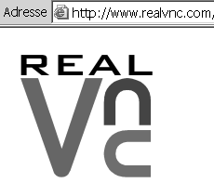
There are plenty packages…
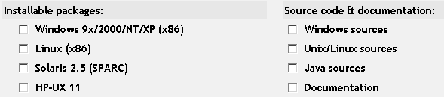
small size is a reliable feature
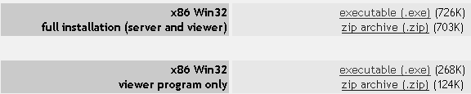
The server program is the program you need to install on the machine you want to access….
The viewer program is the program you need to install on a machine, to accede to a server-installed machine.
You can avoid viewer installation if you can have a recent browser with java machine.

Installing VNC
Install server program
You must start from the full installation server and viewer package, and then double click…
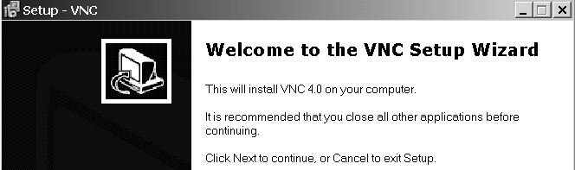

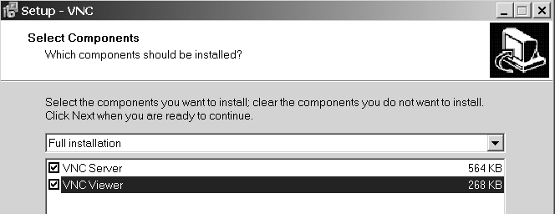
if you want, you can register VNC like a windows service, which is mean that it could be launched at the beginning of setup, and that you can manage from the Windows 2000 classical service interface.
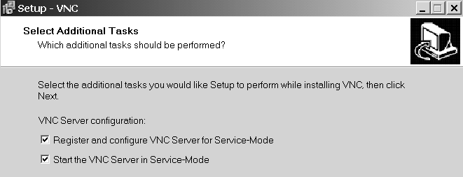

automatically you will have to select a custom parameters if you install the server programm

It's really important to add a password, since VNC is a very powerfull toy!
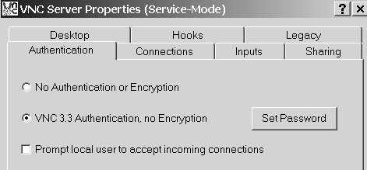

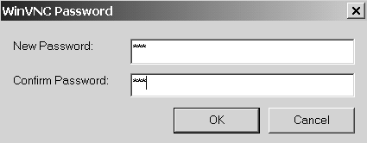

you will see in the task bar the vnc icon

You can see here the service specific menu
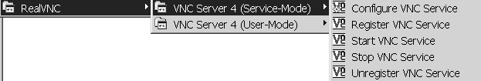

You can see here the vnc user specific menu

Using VNC

Virtual Network Computing
You must have a machine running with a VNC server…and of course you must know the IP address of the machine (or at least the host name)
you have
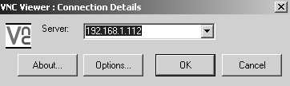 and then
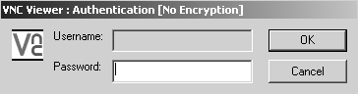
that's all !
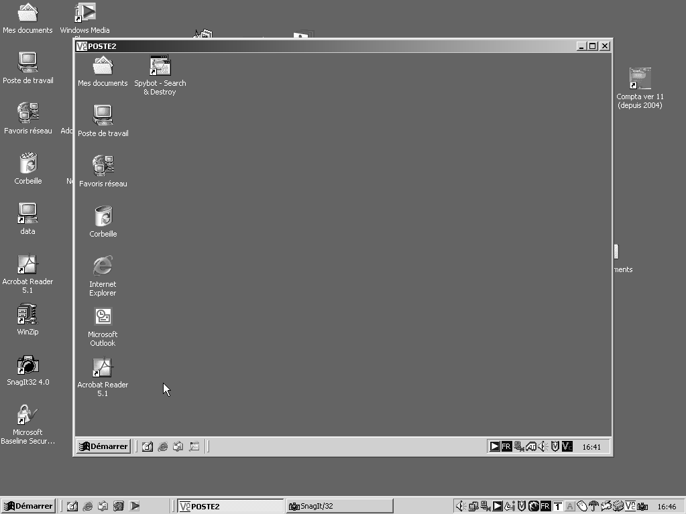
N.B: you can have as many VNC session you want, each one controlling a distant computer….
if you want to send special keyboard touch, like CTRL-ALT-DEL, (end of session for example) as they are catched by your own system, you need to send these touch in a special way.

So you must have right clic on the VNC session you want to use
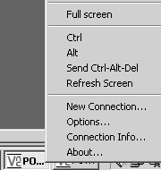
You have you special touch here

Advanced features

register parameters for VNC server
for Configure VNC service double clic on RealVNC icon on the task bar :
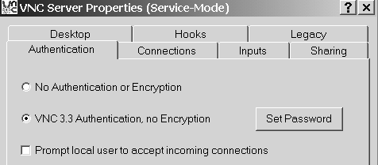

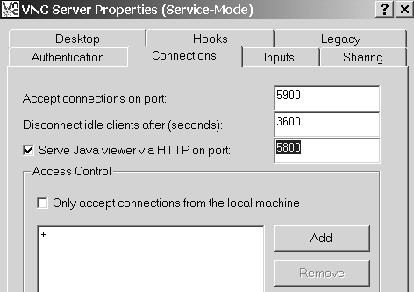

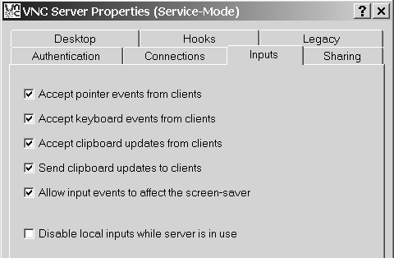

Using a Web connection instead of VNC viewer
Use a VNC Connection via a web browser , you must have a browser who enable JAVA machine, an must know that the default TCP-IP port used by VNC is 5800.
So the URL you have to write seems something like that, for a machine with IP adress 192.168.1.11 :
http://192.168.1.11:5800
you obtain
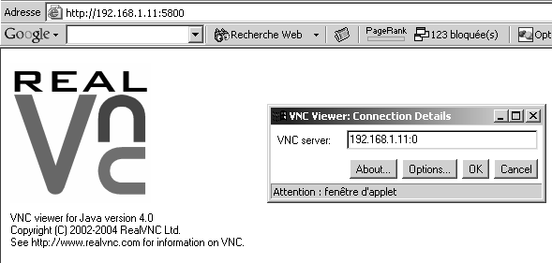
and after identification 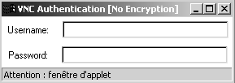
you have quiet a normal VNC screen
N.B: The main difference, is that you don't have the possibility to send keyboard touch or configure screen resolution…

for security if you want, you can disconnect Java viewer

Changing default port of VNC server
you must know that the default TCP-IP port used by VNC is 5800 and 5900.
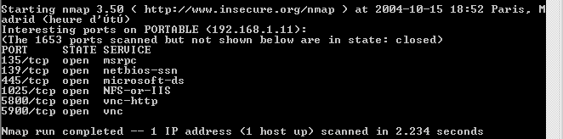

imagine you want ehanced your security, so you want change de default VNC port 5800 by a personnal port 6809, and disconnect responding to a java browser, just configure like this
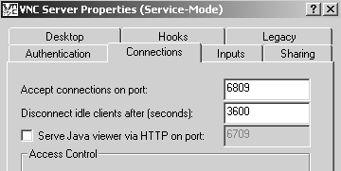

Now, if you want to connect to this particular VNC server, you must specify in your IP address the Ip port by : : like this example :
192.168.1.11::6809
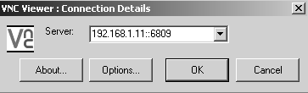

VNC – FireWALL - SSH

register parameters for VNC server
Access to your VNC desktop generally allows access to your whole environment, so security is obviously important. VNC uses a challenge-response password scheme to make the initial connection: the server sends a random series of bytes, which are encrypted using the password typed in, and then returned to the server, which checks them against the 'right' answer. After that the data is unencrypted and could, in theory, be watched by other malicious users, though it's a bit harder to snoop a VNC session than, say, a telnet, rlogin, or X session. Since VNC runs over a simple single TCP/IP socket, it is easy to add support for SSL or some other encryption scheme if this is important to you, or to tunnel it through something like SSH or Zebedee.
SSH allows you to redirect remote TCP/IP ports so that all traffic is strongly encrypted, and this can be combined with VNC. SSH can also compress the encrypted data - this can be very useful if using VNC over slow links. See the 'Using SSH with VNC' page. Zebedee is a similar system which can be sometimes simpler to use. You can find info here.
While we're on the subject of security, you should also be aware that only the first 8 characters of VNC passwords are significant. This is because the 'getpass' call used in the Unix server to read a password has this restriction, and the other platforms have been made compatible with this.
